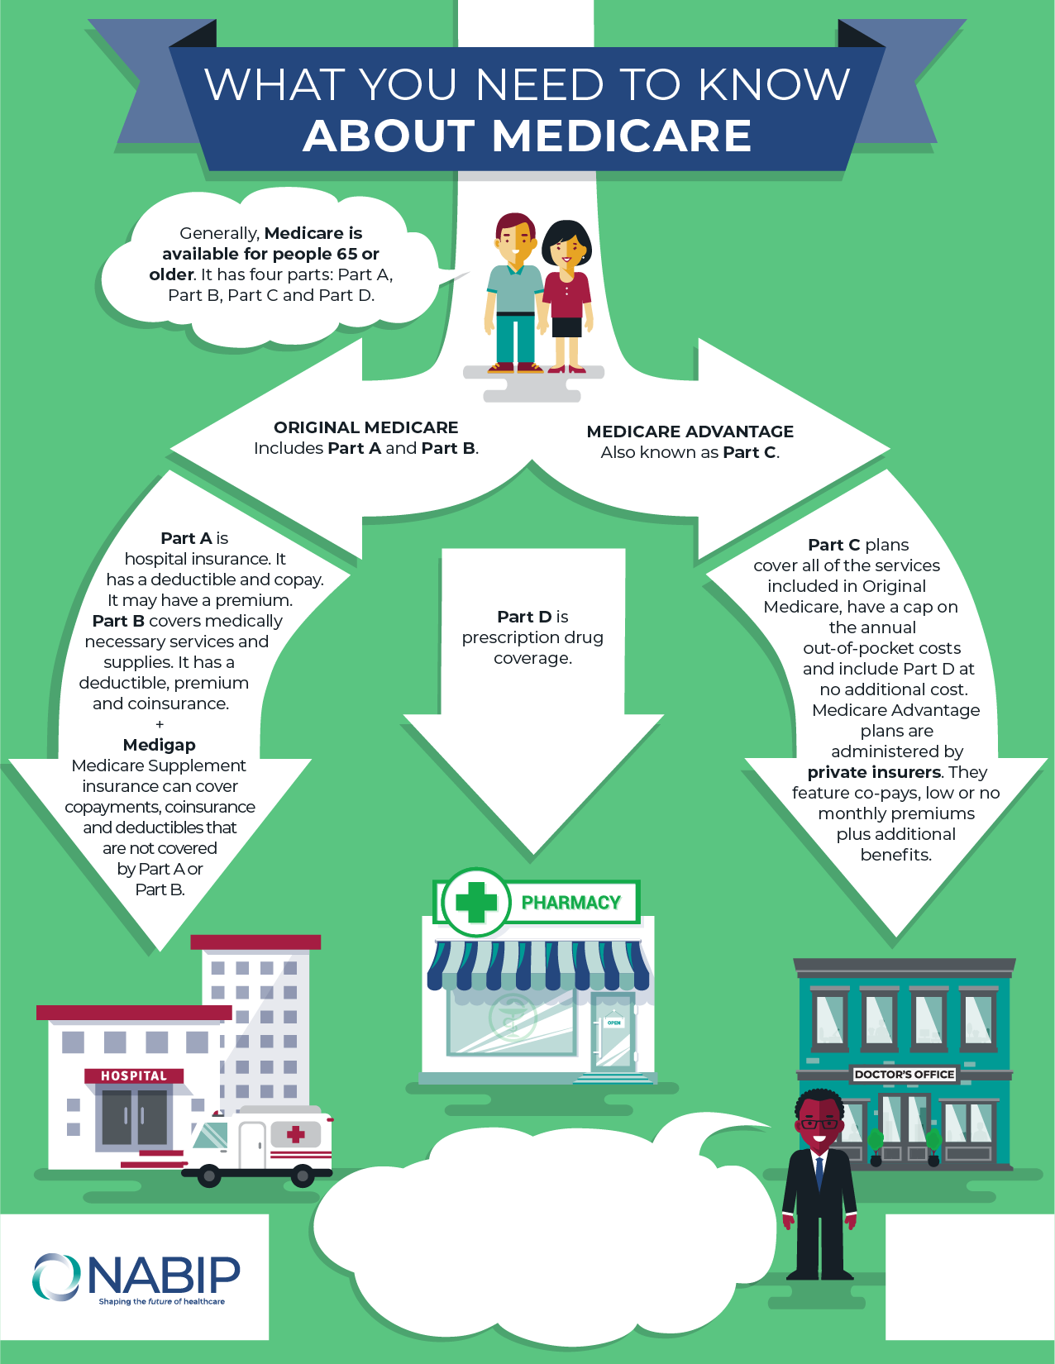

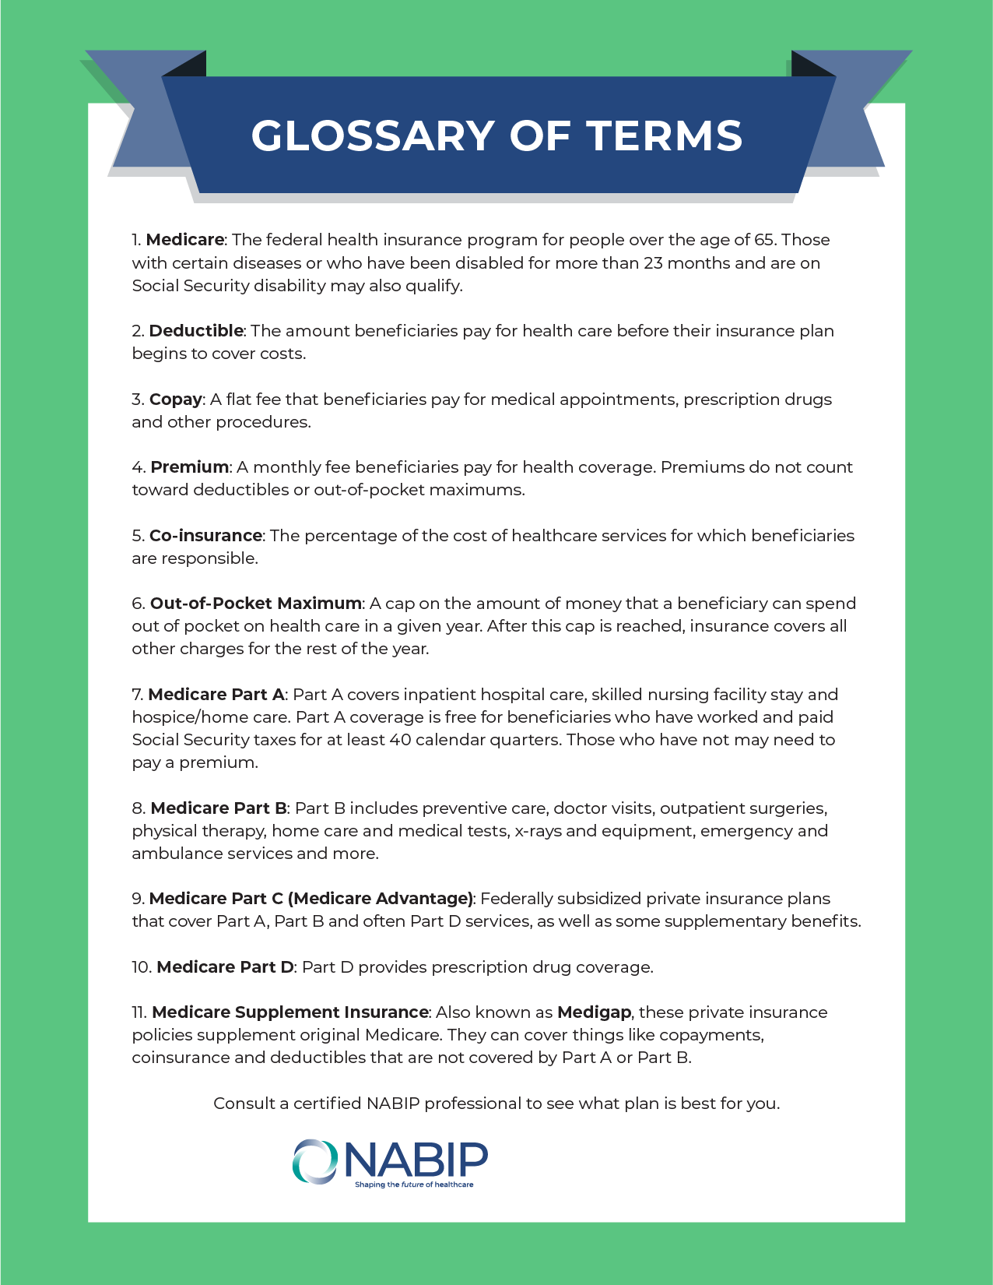

**Ready to Enroll?**  
Talk with a NABIP certified health insurance   
agent to help you make an informed decision.

**Insert Company Name**  
Call **Insert Phone number**  
or email us at **Insert email address**

t **Insert Logo**

**Here**