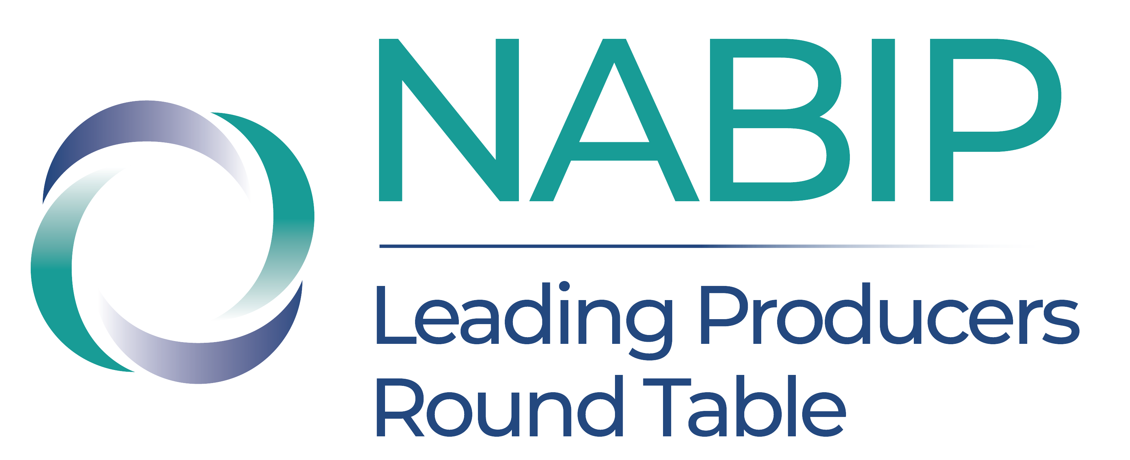
LPRT Social Media Campaign
LPRT Taglines:
Soaring to Success — Honoring top-tier producers in the industry.
Join the Best, Be the Best — Become an LPRT Member.
Where Excellence Meets Opportunity — LPRT.
Social Media:
🏆 Honoring Excellence: LPRT's Recipients
Achievement. Dedication. Expertise. These are the hallmarks of our LPRT awardees. Each member represents the highest standards in business practices and client service. Are you among the next to ascend? Don't wait – applications close on May 31.
🔗 Learn more about joining LPRT
#NABIP #LPRT #Leadership #TopProducers
🚀 Take Your Insurance Career Sky-High!
Are you ready to take your insurance career to the next level? Join us at LPRT where top achievers in the industry gather to access unparalleled benefits and networking opportunities. Don't miss out on this chance to soar to new heights! Apply by May 31.
🔗 Elevate Your Career - Apply Now!
#NABIP #LPRT #ProfessionalDevelopment
🌟 Why Join LPRT? Excellence Awaits!
Step into a circle of champions. As an LPRT member, you’re recognized as the best of the best in the industry. It’s more than a membership—it’s a spotlight on your commitment to excellence and your success. Ready to be acknowledged as a top producer? Don't wait – applications close on May 31.
🔗 Join LPRT Today
#NABIP #LPRT #LeadersInInsurance #CareerExcellence

LPRT Networking Taglines:
Networking with the Best — That's the LPRT Advantage.
Beyond Connections — Engage with Excellence at LPRT.
Meet Challenges with Elite Solutions — Only at LPRT.
LPRT Networking Social Media:
🏅 Aim Higher, Achieve Greater with LPRT
Imagine being part of an elite group where every member is a leader in their field. LPRT isn’t just about recognition—it’s about continuous growth, networking with the finest, and setting new standards of success. Elevate your career with us. Apply by May 31.
🔗 Explore LPRT Membership Benefits
#NABIP #LPRT #ExcellenceInInsurance #ProfessionalGrowth
🌐 Connect with the Best in the Business!
As an LPRT member, you gain access to an exclusive network of highly accomplished professionals. Every connection represents a door to new opportunities and solutions for your business challenges. Ready to expand your professional horizons? Don't wait – applications close on May 31.
🔗 Unlock Your Potential with LPRT
#NABIP #LPRT#NetworkingExcellence #BusinessGrowth
🤝 Network Your Way to the Top with LPRT
Why go it alone when you can have the support of the industry's best? LPRT members enjoy unparalleled opportunities to connect, collaborate, and conquer challenges together. Step into a world of collaborative success and professional growth. Don't wait – applications close on May 31.
🔗 Join Our Elite Network Today
#NABIP #LPRT #EliteNetworking #ProfessionalSuccess

LPRT Benefits Taglines
Save, Learn, and Lead — Experience the LPRT Advantage.
LPRT: Your Gateway to Exclusive Benefits and Industry Recognition.
Develop, Network, Succeed — All with LPRT Membership.
LPRT Benefits Social Media
🎉 Unlock Exclusive LPRT Member Benefits!
As an LPRT member, your journey towards excellence is our priority. Benefit from exclusive quarterly masterclasses, significant discounts on our top events like the Capitol Conference and Annual Convention, and reduced rates on certifications. Plus, get recognized in industry publications as a leader in the field! Don't wait – applications close on May 31.
🔗 Join Us and Reap the Benefits
#NABIP #LPRT #InsuranceProfessionals #CareerDevelopment
🌟 Be Recognized as a Top Producer with LPRT!
Elevate your status in the insurance industry with LPRT. Members enjoy discounted access to our premier events, reduced pricing on professional development, and exclusive educational opportunities. Plus, get featured in industry publications. Don’t miss out on these prestigious benefits! Apply by May 31.
🔗 Sign Up for LPRT Today
#NABIP #LPRT #LeadershipRecognition #InsuranceExcellence
🚀 Transform Your Career with LPRT!
Join LPRT and unlock a spectrum of benefits designed to propel your insurance career to new heights. Save on NABIP’s major events, gain insider access to exclusive quarterly masterclasses, enjoy reduced rates on professional development programs, and achieve recognition in industry publications. LPRT membership is your gateway to becoming a top industry leader. Apply by May 31.
🔗 Become a Member and Reap the Rewards
#NABIP #LPRT #EliteNetworking #InsuranceProfessionals
🌟 LPRT Membership: Your Key to Comprehensive Benefits!
Ready to maximize your potential in the insurance industry? As an LPRT member, enjoy a full suite of benefits: significant savings on registrations for premier NABIP events, exclusive access to quarterly masterclasses, reduced pricing on NABIP certifications, and promotional opportunities in leading industry publications. Elevate your career, enhance your skills, and gain the recognition you deserve with LPRT. Apply by May 31.
🔗 Discover All LPRT Benefits and Apply Today
#NABIP #LPRT #TotalCareerAdvancement #InsuranceLeadership

LPRT is Top Taglines
Top Views, Top Peers, Top Opportunities — Experience It All at LPRT.
From the Top, Lead the Field — Join LPRT.
See the Best, Be the Best — Climb with LPRT.
LPRT is Top Social Media
🌟 Reach the Top with LPRT
The view from the top is unmatched, and so is the journey to get there. As an LPRT member, you join the ranks of those who define success in our industry. Elevate your career to new heights and see your professional opportunities grow. Don't wait – applications close on May 31.
🔗 Ascend with Us at LPRT
#NABIP #LPRT #TopAchievers #IndustryLeaders
🔝 Experience the Summit of Success with LPRT
Being at the top isn’t just about the view—it’s about the prestige, the influence, and the opportunities that come with it. LPRT members know this because they live it every day. Are you ready to join them? Apply by May 31.
🔗 Claim Your Place Among the Best
#NABIP #LPRT #ViewFromTheTop #SuccessStory

