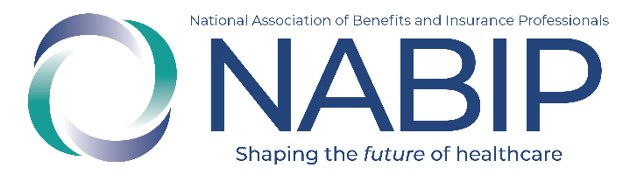
PY27 NABIP Medicare Certification
Social Media Campaign

Overview:
NABIP’s 2027 Medicare, Medicare Products and FWA Certification launches on June 22 and will be available to all agents and brokers. Built by brokers, for brokers, this certification is CMS-compliant, carrier-approved, accepted by all four major national carriers—UnitedHealthcare, Aetna, Elevance Health, and Humana—and filed for CE credits in all 50 states and DC. Priced at just $100, it will provide unmatched value, flexibility, and real-world relevance for those preparing for the 2027 Medicare season.

This national social media campaign is designed to spotlight the certification’s credibility, convenience, and professional advantage—while positioning NABIP as a leading voice in Medicare broker education.

Call to Action:
We encourage all NABIP chapters and members to actively participate in the campaign by:
- Posting the launch content on your social media platforms beginning June 22
- Continuing promotion using the pre-designed posts and graphics provided in the campaign toolkit
- Engaging with NABIP’s national posts by liking, sharing, and commenting to boost visibility
- Highlighting the bonus incentive—the first 250 to complete the certification will receive an exclusive NABIP-branded Medicare Certification pin

Need help drafting content? Use the NABIP's Media Wizard to generate high-quality, tailored social posts in seconds.

Announce Launch of PY2027 Medicare Certification (Mon., 6/22, Wed., 6/24 &Fri., 6/26)
Post 1 (Mon., 6/22)
Social Image:

Social Copy:
🚨 Launch Day Is Here! The 2027 NABIP Medicare, Medicare Products and FWA Certification is officially LIVE!
Created by brokers, for brokers, this certification is your edge in today’s competitive Medicare market:
The 2027 Plan Year Certification is:
✅ CMS-compliant — fully satisfies requirements to sell MA plans
✅ Accepted by all four major national carriers — UnitedHealthcare, Aetna, Elevance Health, and Humana
✅ Carrier-approved — accepted by most regional and national insurers
✅ Filed for CE credits in all 50 states + DC
✅ Accessible online — learn at your pace
✅ Just $100 for the full package — training, CE, logo, and access
✅ Includes a branded certification logo to use in client outreach and marketing

💬 “Much more useful than other programs—every agent should take this!”
📊 75%+ of brokers say they’re extremely likely to recommend it.
✨ BONUS: Be one of the first 250 to complete the certification and receive an exclusive NABIP-branded Medicare Certification pin—a mark of your expertise and commitment.
📢 Show your clients—and carriers—you’re a step ahead.
👉 Signup today: https://www.nabiptraining.org/nabip/medicare
#NABIPCertified #MMACR #BuiltByBrokers #CarrierApproved #MedicareAdvantage #CECredits #AEP
Post 2 (Wed., 6/24)
Social Image:
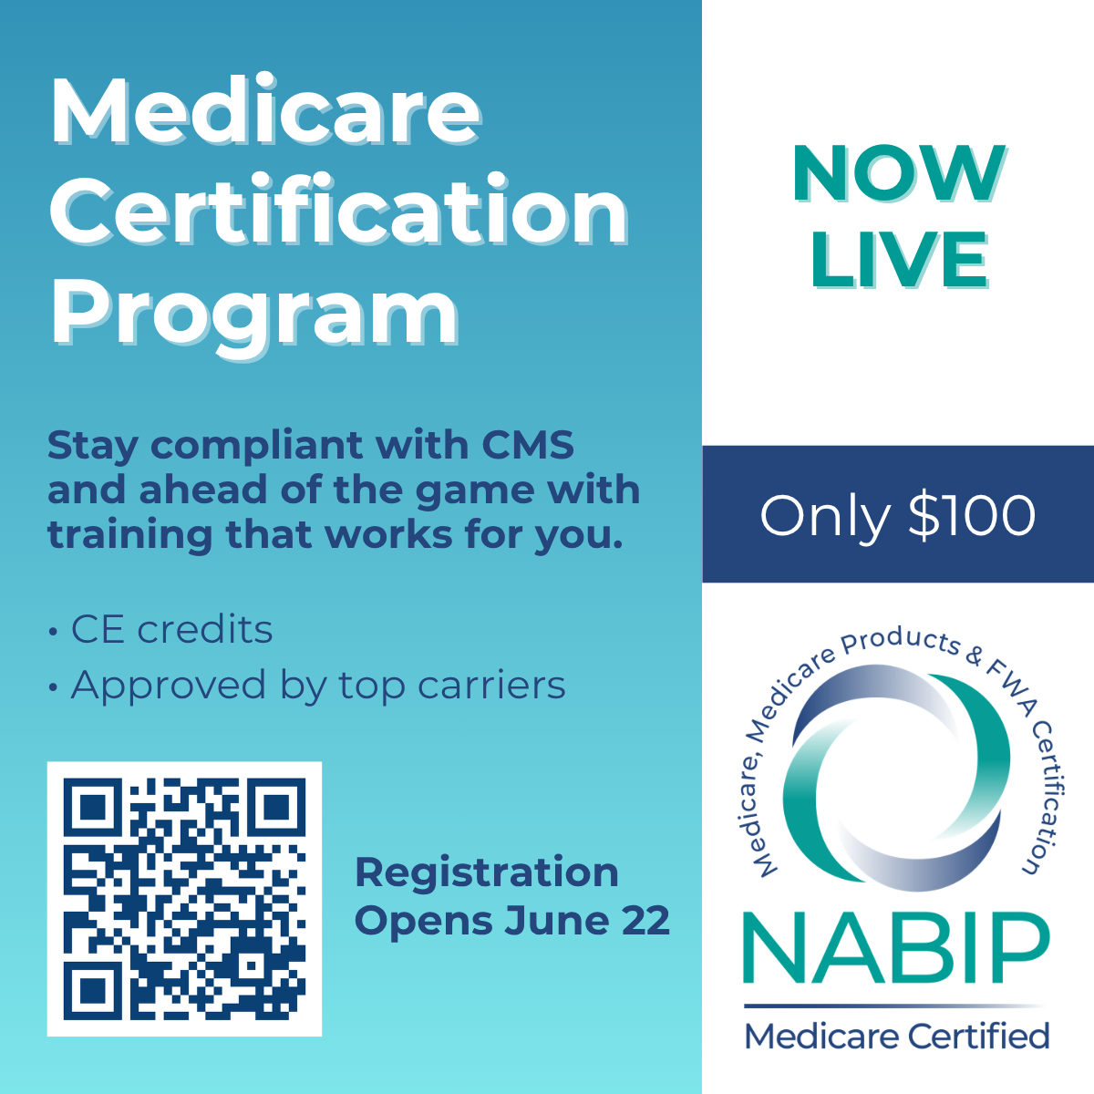
Social Copy:
✨ Why do brokers love NABIP’s new certification?
✔ 76% rated it “high” or “very high” quality
✔ Top words used: “Useful,” “Easy to access,” “Great value”
✔ Built by brokers, for brokers
✔ Accepted by all four major national carriers — UnitedHealthcare, Aetna, Elevance Health, and Humana
📲 Self-paced. Carrier-approved. Just $100.
🗓 Certify now for the 2027 Medicare Advantage season.
🔗 https://www.nabiptraining.org/nabip/medicare
#MedicareCertified #CarrierApproved #NABIP #BrokersMatter
Post 3 (Fri., 6/26)
Social Image:
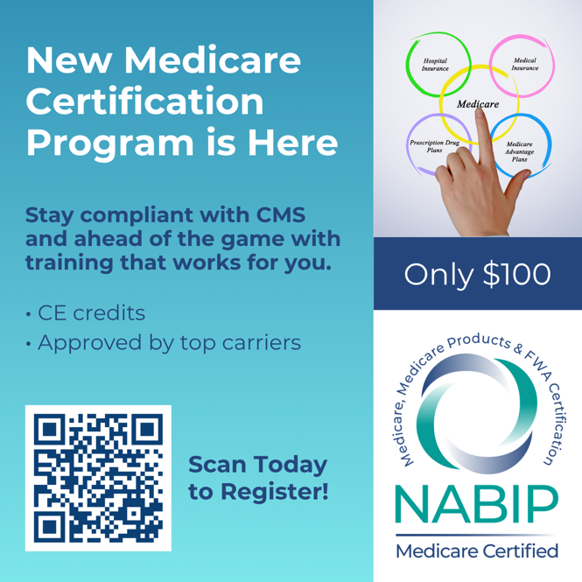
Social Copy:
Certification isn’t just a checkbox — it’s a competitive edge.
NABIP’s new Medicare Advantage training gives you:
✅ A branded certification logo for your marketing
✅ CE credits nationwide
✅ A course built around real-life broker experience
💡 Get certified today — and start AEP ready to lead.
🔗 Learn more: https://www.nabiptraining.org/nabip/medicare
#MedicareAdvantage #NABIPCertified #AEP2027 #CEcredits #BuiltByBrokers
Other Socials to Post:
Required by CMS — Built for Brokers
Medicare Advantage certification isn’t optional — but how you get certified makes all the difference.
NABIP’s new certification program gives brokers more:
✅ A branded certification logo to boost your marketing
✅ CE credits nationwide
✅ Built around real-world broker experience — not fluff
💡 Stay compliant. Stand out. Succeed.
🗓 Now available for the 2027 plan year.
🔗 Get started: https://www.nabiptraining.org/nabip/medicare
#MedicareAdvantage #NABIPCertified #CEcredits #BuiltByBrokers #AEP2027
Other Social Images:
