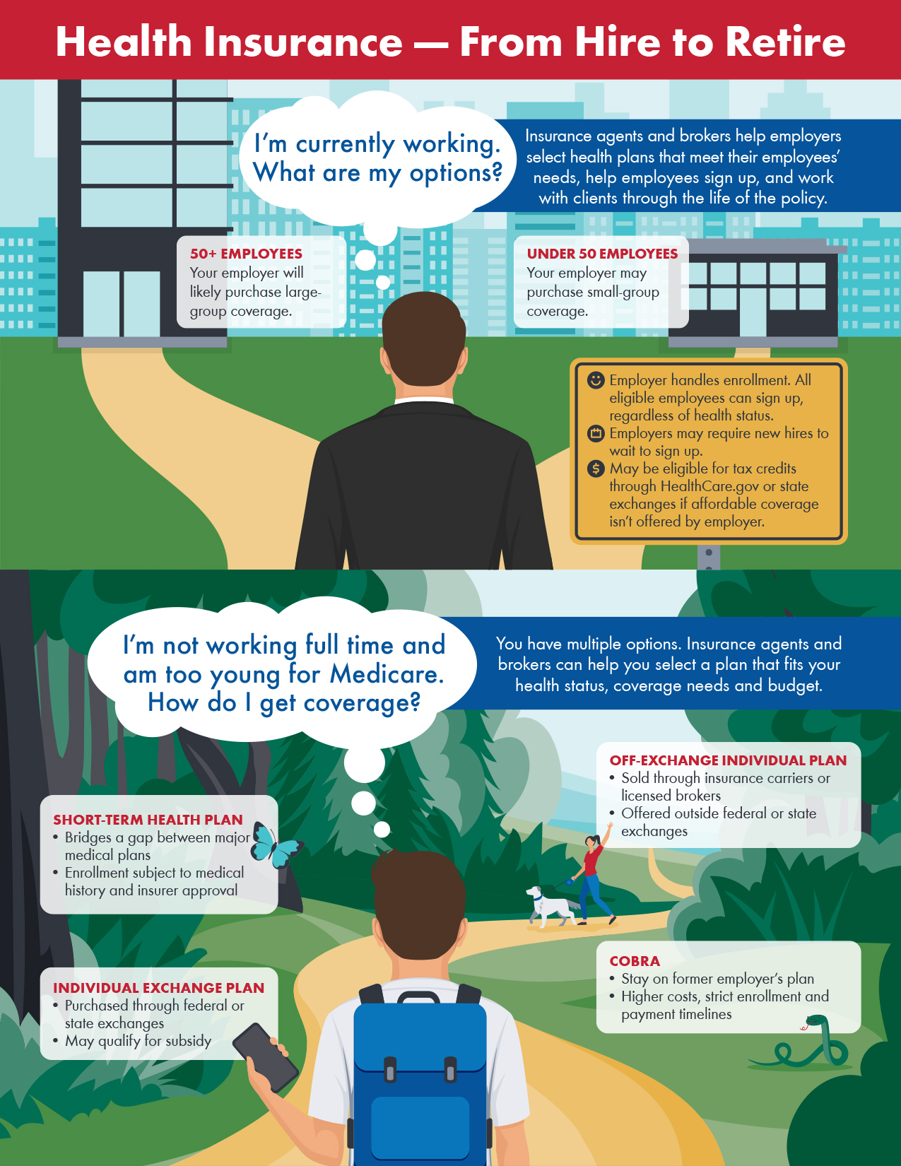

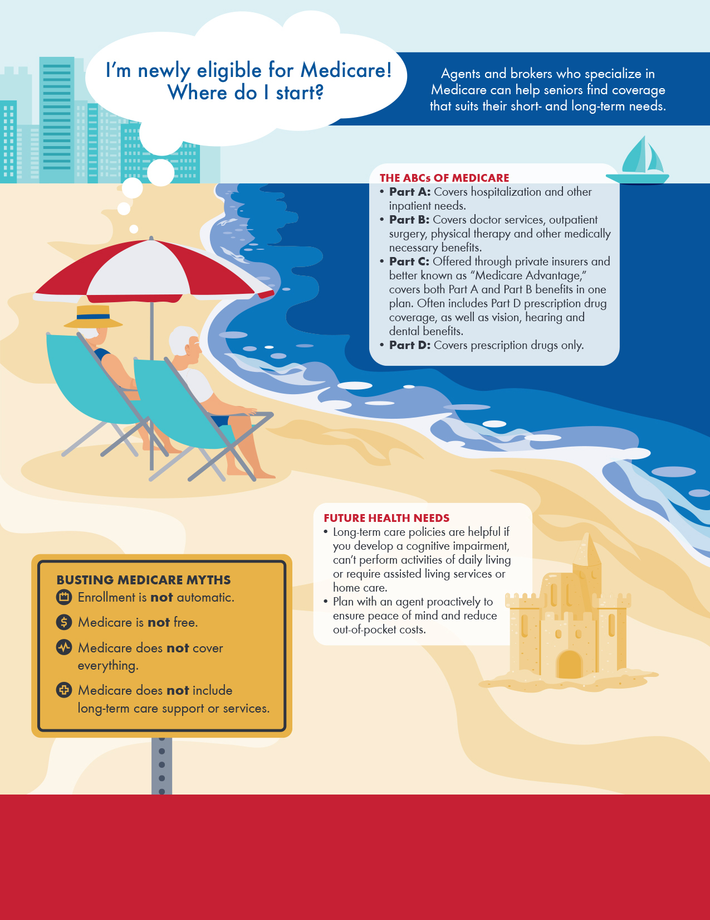

No matter what stage of life you’re in, a licensed insurance agent or broker can help you find your way through the healthcare marketplace.

For more information, contact**: Firstname Lastname at ACME Services  
555-555-5555, email@email.com**