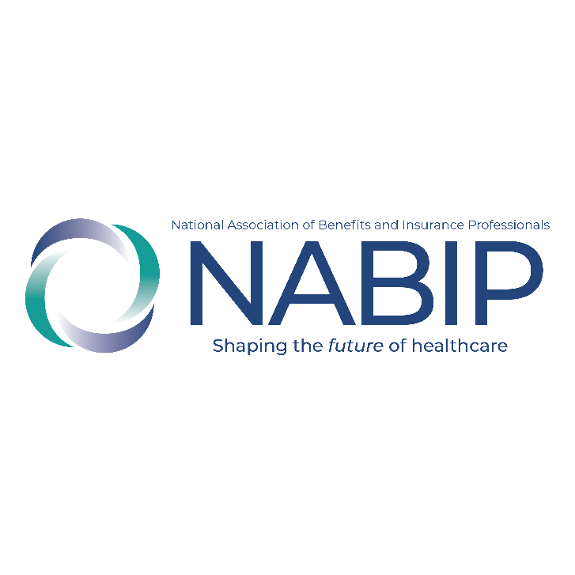
NABIP Errors & Omissions
Program Social Media

Social Media Image
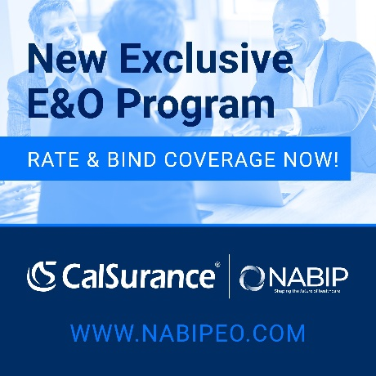
Post One:
Exciting news for @NABIP members! We have partnered with @CalSurance to introduce a new E&O Insurance Program with a range of improved benefits. Now, you can apply, quote, and bind your insurance online in minutes. Learn more and get a quote at www.nabipeo.com #NABIP #CalSurance #memberbenefits
Post Two:
Exciting news for @NABIP members! We have partnered with @CalSurance to introduce a new E&O Insurance Program with a range of improved benefits. Now, you can enjoy preferred discounted rates and have the peace of mind of an admitted carrier rated A by AM Best. Learn more and get a quote at www.nabipeo.com #NABIP #CalSurance #memberbenefits
Post Three:
Exciting news for @NABIP members! We have partnered with @CalSurance to introduce a new E&O Insurance Program with a range of improved benefits. With defense outside the limits of liability and first-dollar defense, you can feel confident in your coverage. Learn more and get a quote at www.nabipeo.com #NABIP #CalSurance #memberbenefits

